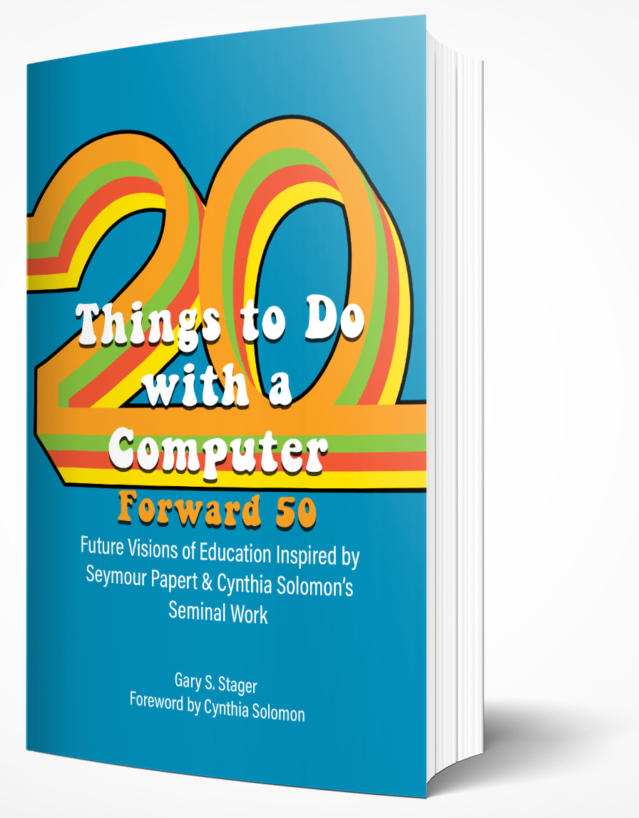
Contact:
Sylvia Libow Martinez, CMK Press
sylvia@cmkpress.com | 310-567-4243

All-Star Book Celebrates 50th Anniversary of a Revolutionary Text
Twenty Things to Do with a Computer Forward 50
Future Visions of Education Inspired by Seymour Papert and Cynthia Solomon’s Seminal Work

Torrance, CA – Nov 15, 2021 Twenty Things to Do with a Computer Forward 50 is available immediately from Constructing Modern Knowledge Press. This book marks the 50th anniversary of a seminal paper by Cynthia Solomon and Seymour Papert. Published in 1971, Twenty Things to Do with a Computer set the course of education for the next fifty years and beyond. Gary Stager curated the new book, Twenty Things to Do with a Computer Forward 50, as a celebration of the vision set forth by Papert and Solomon a half-century ago. Four dozen experts from around the world invite us to consider the original provocations, reflect on their implementation, and chart a course for the future through personal recollections, learning stories, and imaginative scenarios.

Twenty Things to Do with a Computer Forward 50 can inspire parents, educators, and aspiring teachers to make the world a better place for learning. It is a perfect text for graduate education programs.

In 1971, Solomon and Papert predicted 1:1 personal computing, the maker movement, the rise of computational thinking, children programming computers, robotic construction kits, computer science for all, and integrating computing across the curriculum. All of this, years, or even decades, before such notions became more commonplace. Even more importantly, Twenty Things situated the ideals of progressive education in a modern context. Papert and Solomon demonstrated how computing could be creative, humane, whimsical, childlike, and a way to learn “everything else,” even ideas on the frontier of mathematics and science.

Fifty years later, we are still striving towards these ideals. The authors of these essays lay out compelling arguments and practical examples of what the future of education can look like when we stand on the shoulders of giants. Twenty Things to Do with a Computer Forward 50 is an effort to share timeless, powerful ideas with future generations seeking a more creative, personal, empowering, and meaningful educational experience for young people.

This book is a must-read for: educators, school leaders, preservice teachers, teacher educators, policymakers, technology developers, librarians, and parents.

About the Authors
Contributors to this book include scholars and tech pioneers who worked with Papert and Solomon in the 1970s, phenomenal classroom teachers, inventors, researchers, school administrators, university professors, and educational technology leaders. Essays in this collection offer multiple pathways for modern school reform. Authors include Cynthia Solomon, Sugata Mitra, Conrad Wolfram, Audrey Watters, David Thornburg, David Loader, Yasmin Kafai, Dale Dougherty, Nettrice Gaskins, Dan Lynn Watt, Molly Lynn Watt, Gary Stager, Artemis Papert, Stephen Heppell, along with forty other brilliant thinkers and legendary educators.

Twenty Things to Do with a Computer Forward 50 is available in paperback and hardcover versions at all online retailers, or wholesale at Ingram and Constructing Modern Knowledge Press at sales@cmkpress.com.

ISBN: 978-1-955604-00-0 (paperback) MSRP $34.95 ISBN: 978-1-955604-01-7 (hardcover) MSRP $59.95

** To request a review copy of the book or arrange an interview, please email sylvia@cmkpress.com **
###

